**SQL JOINS:**

Combine rows/columns from two or more tables, based on a related column between them in a database.

1. Inner join:
2. Left join:
3. Right join:
4. Self join:
5. Cross join:

**1.Inner join:**

Returns rows when there is a match in both tables.

Inner join is also called join.

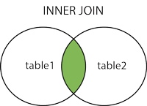

Syntax:

SELECT *column_name(s)*  
FROM *table1*  
INNER JOIN *table2*ON *table1.column_name*=*table2.column_name*;

**2.Left join:**

Returns all rows from the left table, even if there are no matches in the right table.

Left join is also called left outer join.

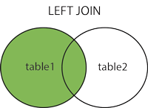

Syntax:

SELECT *column_name(s)*  
FROM *table1*  
LEFT JOIN *table2*ON *table1.column_name*=*table2.column_name*;

**3.Right join:**

Returns all rows from the right table, if there are no match in left table.

Right table also called right outer join.

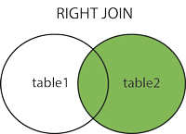

Syntax:

SELECT *column_name(s)*  
FROM *table1*  
RIGHT JOIN *table2*ON *table1.column_name*=*table2.column_name*;

**4.Self join:**

A self join is a regular join, but the table is joined with itself.

Syntax:

SELECT *column_name(s)*  
FROM *table1 T1, table1 T2*  
WHERE *condition*;

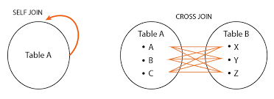

**5.Cross join:**

Cross join is used to combine each row of the first table with each row of the second table.

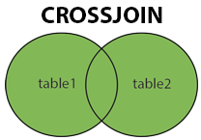

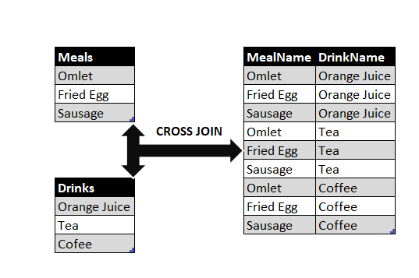

Syntax:

SELECT *column_name(s)*  
FROM *table1 T1, table1 T2*  
WHERE *condition*;